Audio Builders Workshop

“Cmoy” headphone amplifier built on BREADBOARD KIT

### Introduction

This documents describes a project that can be built with the ABW breadboard kit. You should read the documents provided with that before building this circuit as those documents explain details about how to use a breadboard and identify the parts.

This example is intended as a beginner level to introduce you to assembling your own electronic projects. If you received this kit at an AES/ABW event then most likely there are volunteers on hand to answer questions while you follow this guide to assemble the kit.

If you received this kit for assembly at home many general electronic assembly questions can be answered from resources found on the internet.

If you get stuck and need help please post your question on the Audio Builders Workshop’s Facebook page <https://www.facebook.com/groups/AudioBuildersWorkshop/>

Looking for the projects? Please see:

<https://github.com/AudioBuildersWorkshop/BreadboardKit/>

### About the audio builders workshop (ABW)

The ABW is a working group of the Boston Chapter of Audio Engineering Society. The ABW promotes interest in electronics construction and design for applications with audio. In addition to kit building the ABW sponsors all day seminars on various technical topics related to audio and recording of audio. The Boston AES also runs shorter (1 to 2 hours) lectures, company visits, and networking events once or twice a month. All ABW and Boston AES events are free to attend, though there are materials fees for purchasing kits.

Many of the events are posted on the ABW You Tube channel, including a substantial back catalog of talks: https://www.youtube.com/audiobuildersworkshop

### About this project

This project is a stereo headphone amplifier with input volume control. It’s based directly on the information published here:

<https://tangentsoft.net/audio/cmoy/>

There is considerable information on that website that you may find helpful and we suggest looking at that first if you have questions about the design.

### More info

<https://www.audiobuildersworkshop.com/>

Licensed under 

## Precautions

The integrated circuits (IC) used in the project can be damaged by static electricity. You should assemble this at a static free workstation. If you don’t have that you should touch a metal object before picking up any components. If you feel a static discharge then your work area is definitely not static safe and you should at least get an ESD grounding wrist strap. Even if you don’t feel a static discharge your body may accumulate a charge that can damage the IC used in this project; touching a large, grounded metal object first reduces the chance of damage but is not a substitute for proper static control.

# Parts identification -What you’ll need

Please see the ABW build kit manual for more information about identify and using the parts.

While kits are usually made with parts from the same manufacturer so look like these pictures, there is a chance that we had to substitute parts and the will have a different color or appearance than what is pictured here.

The tables also include the *Reference Designator(s)* that matches the schematic.

## Resistors

The resistors in the kit are generic carbon film types. While fine for generic audio use on a breadboard, if you decide to build a version of this circuit on to a PCB (printed circuit board) you should use metal film resistors. In a breadboard circuit the intent is to show functionality – it is very difficult to make a breadboard operate at the same level of performance as a PCB as breadboards have a high level of parasitic capacitance and resistance between connections.

That downside is more than balanced by the breadboard’s easy of use and easy experimentation compared to a PCB with components soldered down.

### Fixed resistors

These can be installed in any orientation.

|  |  |  |
| --- | --- | --- |
| R6, R10 - 1KΩ :  Brown Black Red | R1, R2 – 4.7KΩ :  Yellow Violet Red | R5, R6 - 10KΩ :  Brown Black Orange |
| R4, R8 - 100KΩ :  Brown Black Yellow |  |  |

### Variable resistors

When installed in the board we will want full counter clockwise rotation to be the ‘no signal’ position and the full clockwise position to the ‘loud as hell’ position.

|  |
| --- |
| Pot, 10 K ohm, Audio taper |

## Capacitors

### Non-polarized

Non-polarized capacitors can be installed in either orientation.

|  |
| --- |
| C4, C5 - 0.1 uF (100 nF) film |

### Polarized

Polarized capacitors have a stripe indicating the negative (-) side. They are large enough that the values are imprinted on the case.

|  |
| --- |
| C1, C2, C3 - 220 uF |

## ICs

This component can be damaged by static electricity.

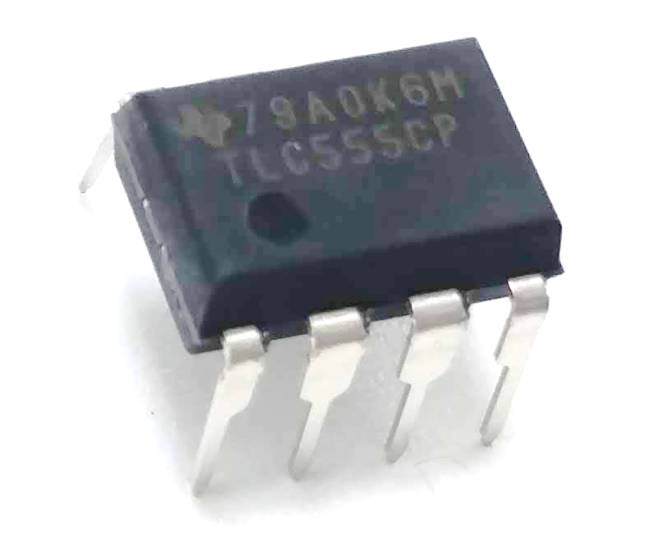

Pin 1 indicator

It is critical to install the IC correctly as installing it backwards may release all of the special magical smoke inside of the parts.

|  |
| --- |
| RC4558 Op-amp |

In case you overlooked this in the intro guide pins are number counterclockwise, like this: 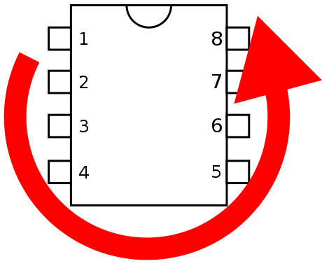

## Other parts

|  |  |
| --- | --- |
| Hookup wire | 9V battery clip |
| Mini phone (stereo) jack. Actual jack may be a different color. |  |

The 1/8” mini-phone jack has three tabs on the bottom that mate to the bread board. When viewed from front/above as shown in the photo below, the signal order is right, n/c, ground, n/c, left. Usually red indicates right and white indicates left, but on breadboard convention is also to use red for the positive power connections. Chose whatever color you want, but if you pick red, don’t wire it to power!

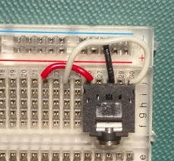

# The schematic

Don’t worry if you’re not familiar with reading schematics yet. As you do more circuits you’ll start to pick up on the way schematics represent the function of a circuit and the physical realization of that with actual parts. Google is your friend for finding many excellent tutorials on understanding schematics.

The 1/8” jack shown in the schematic has more connections than the jack that may be in your kit. That’s OK, we just need two wires to the jack, the tip (left if it was stereo) and the ground connection. Please see the ABW build kit introduction document for more details about using the 1/8” jacks.

We’ll show the schematic in two parts so that it is easier to read on letter size paper. The symbol with the little lins and GND represents the ground connection. In many systems this signal is connected to the negative side of the power supply or battery. That is NOT the situation in this circuit design.

Power connections on the schematic are indicated by a little bar symbol with the either 9V for the battery’s positive connection or 0V for the battery’s negative connection.

This also means you can not power this circuit with a bench supply or wall wart that might ground the negative side. It must be battery powered (or equivalent isolated supply).

More details are available from the source documents in the ABW github repo:

<https://github.com/AudioBuildersWorkshop/BreadboardKit/tree/master/Projects/CMoyAmplifier>





## Pictorial view

The pictorial view shows how the circuit could be constructed on the breadboard. There are many possible ways to place the components and wire them up that are all electrically identical to the schematic. If you’ve forgotten how a breadboard connects the holes together please review the supplemental materials.

The design here is a little different in that the top blue rail is used for the ground connection and the bottom blue rail for the 0V connection (battery negative terminal) and the bottom red rail for the battery 9V connection (battery positive terminal).

This circuit is a little crowded on the breadboard and you’re almost certainly going to knock the volume pots off more than once when inserting other components. You may also need to shift components as you add more. Remember with a column all pins are the same on each half of the board, as are all pins in the rails. You don’t need to use the exact same physical holes as shown, but they must be electrically the same (i.e. connected internally on the breadboard) for the circuit to work. The transparent breadboard normally used in the kit can help you visualize those built in connections of a breadboard..

# Overview of assembly steps

There’s really no one way to build these circuits. We do suggest you take out the parts you need ahead of time from the kit and put them in a separate box (or a plate if you’re at an event) so you know if you left out a part, etc.

Likewise it’s convenient to make up the wire jumpers you need before you start. You may need to cut a few more as you go but staying focused on the assembly steps is key to not overlooking anything.

The battery should be the very last thing you connect, and only after triple checking everything else.

## Things to think about before you start

Putting in ICs backwards - that might break them. Pay really close attention to when you put that part in.

Polarized capacitors also should not be connected backwards. If you connect the diodes backwards no harm will be done but the circuit won’t work.

Before you connect the battery check the IC and polarized cap again. And then ask a friend to check.

## And starting

Place the breadboard in front of you with column 1 on the left and column 30 on the right.

We’ll install the five main components first, and then start connecting them together, either with jumpers or with other components.

In electronics inputs are traditionally placed on the left and outputs on the right. You’ll notice the schematic was drawn this way too.

Starting on the far left side of the breadboard, plug in the miniheadphone jack (J1) so that you can still access a column of pins above it. Place it in the upper half with the jack facing you (see picture if not sure).

Next move a row to the right and plug the two pots in. It has two large tabs that won’t fit in the board. You can place those in the gutter between the two rows (you may still need to bend the tabs or the pins slightly to make it all fit).

Next we’ll install the op-amp IC – if not wearing a grounding wrist strap, as a precaution, touch some metal (preferably grounded) before reaching for it. Move another 6 holes or so to the right. Arrange the IC so pin 1 is in the lower left as you face the board. This means the notch (or dot) is on the left – refer back to the earlier diagram if you’re unsure. We’ll use column 20 as that’s what the example drawing shows, but you can use any location that leaves enough room for the parts that need to go around it.

On the far right side of the board install the second jack. You may want to look ahead at the picture to see if your placement matches.

## Power connections and parts

Next we’re going to add the components associated with the three power connections: 9V, GND (ground), and 0V. There are a far number of jumpers to install so you may want to look at the pictures at the end to help you. Again we’ll refer to the jumpers by their position in the fritzing diagram, but please adjust these to where you installed the components.

We’re going to create a section in the middle of the board that represents the GND connection as a lot of components connect to it and the horizontal rails are not always convenient for this circuit. We’ll use black wire for the GND connections. Do not confuse this with the battery’s black wire, which in this circuit will be the connection labeled 0V.

We’re going to use rows 16 and 17 in the lower half and row 17 in the upper half. Install a small jumper between row 16 and 17 in the lower half (column a-e). Install a jumper from row 17 in the lower half to row 17 in the upper half. Now install a jumper from row 16 to the top rail (blue stripe).

It will look something like the black wires in the zoomed in example shown below.

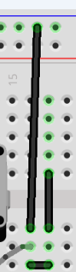

We’ll now make all of the other ground connections so that those wires sit below all of the other components that will get added, which will make it easier to change things around later if you want to experiment.

Connect the two pin 1’s of the pots together with a short black jumper, pin 1 is the terminal on the left when installed as shown in the pictures. Then connect pin 1 of the pot on the right to the GND connection in row 16.

Connect the center pin of J1 (input jack) to the top blue rail. Refer back to the introductory guide about wiring the jack if you’re unsure how to connect it.

Repeat this step for J2, the headphone output.

Now we’ll make the connections to the 9V and 0V power signals.

Connect a black jumper wire from pin 4 of the IC (right most pin facing you) to the blue stripe rail (0V) on the bottom of the breadboard.

Connect a red jumper wire from pin 8 (left most pin on upper side) to the red stripe rail (9V) at the bottom of the breadboard.

We’ll add the battery clip (no battery should be connected!). Place the black wire in to one of the holes on the bottom negative strip (blue stripe, this is the 0V connection on the schematic). Place the red wire in to the adjacent strip marked with the red stripe (this is the 9V connection on the schematic). Do this on the far left end to keep the wires out of the way. As the wires sometimes do lift out of the holes a bit we suggest not placing them across from each other to avoid a short between the two.

Next insert C1 (220 uF capacitor) with the negative lead in the blue stripe holes (0V) and the positive lead in the red stripe (9V), do this near where the battery connection was made on the left side of the board (again please see the pictures at the end of this sub-section).

Insert C2 (220 uF capacitor) with the negative lead in a row 17 GND hole and the positive lead in the red stripe strip (9V) at the bottom of the breadboard.

Insert C3 (220 uF capacitor) with the negative lead in the blue stripe strip (0V) at the bottom of the breadboard and the positive lead in a row 16 GND hole.

Insert R1 (4.7 KΩ resistor, yellow violet red ) with one lead in a row 17 GND hole and the other lead in the red stripe strip (9V) at the bottom of the breadboard.

Insert R2 (4.7 KΩ resistor) with one lead in the blue stripe strip (0V) at the bottom of the breadboard and the other lead in a row 16 GND hole.

At this point your board should look something like the next diagram. We know the 1/8 mini-phone connector doesn’t quite look like what’s in the diagram but it’s what the Fritzing tool wants to show so we’re just going to go with it. A photo is also shown to help you review your layout.

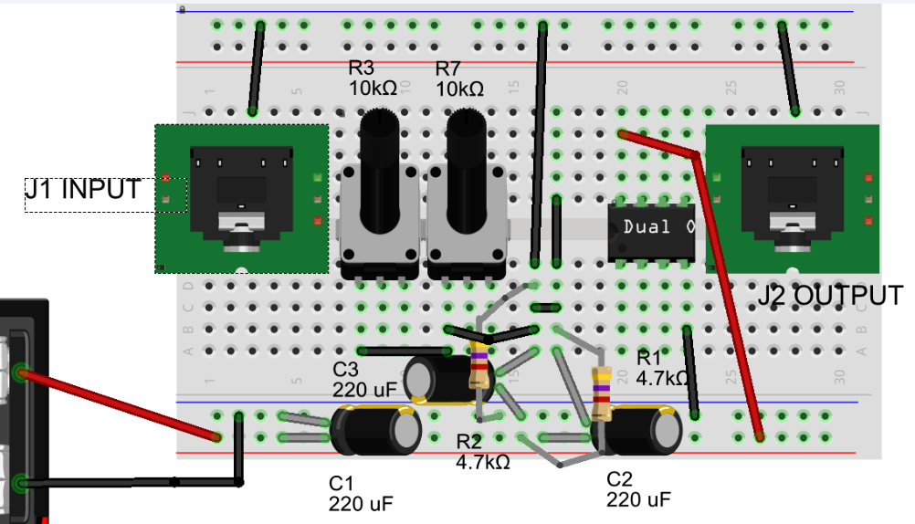

Pin 1

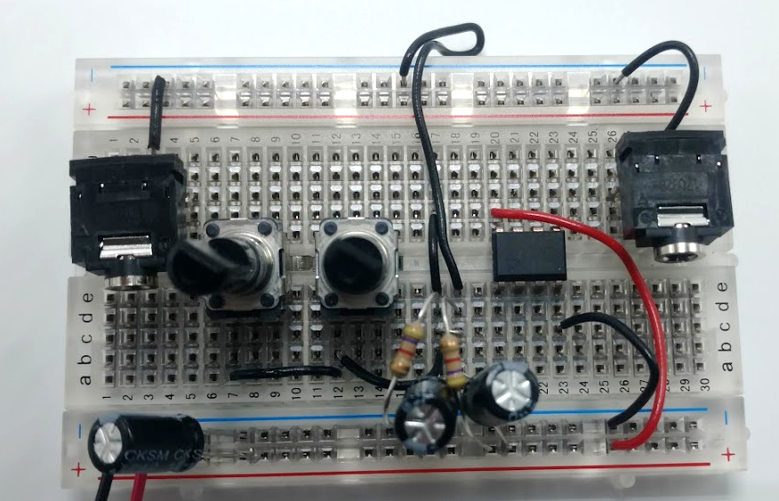

Front view (i.e. column 1 on the left, which is how you should normally view the board).

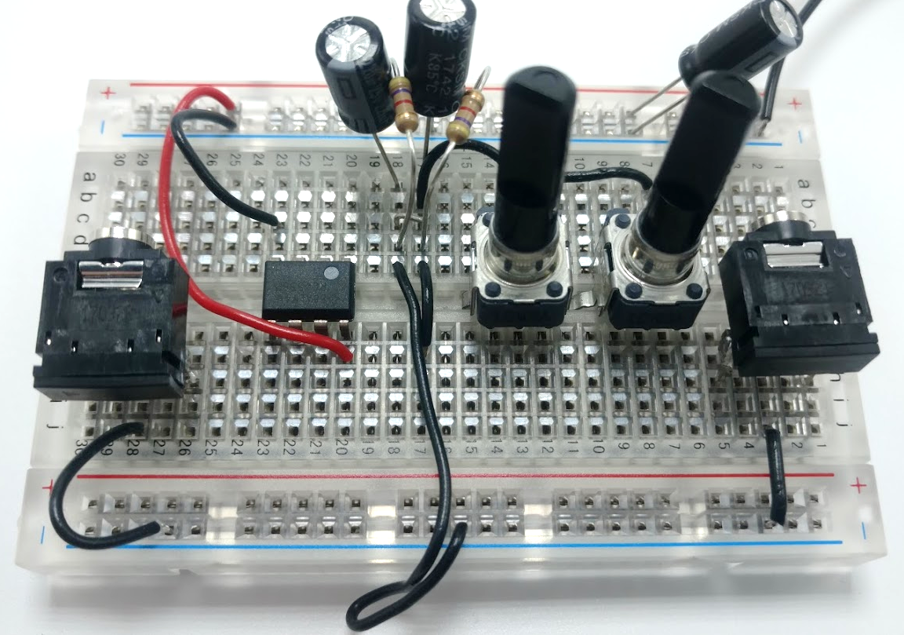

Rear view

## Connect the components associated with the input

With the basics complete we’ll now connect up everything associated with the input portion. Make sure component leads are arranged to not short against other components. We’ll work left to right across the schematic.

Color of wire isn’t important but we’ll describe it as shown in the diagrams.

Connect a yellow jumper from the right (ring, far left end) input of connector J1 to terminal 3 (right pin) of pot R7 (pot on the right).

Connect a white jumper from the left (tip, right end) input of J1 to terminal 3 (right pin) of pot R3 (pot on the left).

Components C4 and C5 (the 0.1uF capacitors, red rectangles in real life but show as tan circles in Fritzing) don’t have leads long enough to reach the place they need to connect to. So we’ll place one end in the desired connection point and then use a blank row for the other connection. A short jumper to the desired connection will complete the circuit.

It’s also going to start getting crowded around the middle of the board so watch out for shorts between components or accidentally disconnecting them.

Insert one end of C4 (0.1uF film cap) in the row of holes of pin 5 of the IC (row 23 in this example). Insert the other end in to row 19 (col a-e). Then connect a short yellow jumper from row 19 (col a-e) to terminal 2 (center) of pot R7.

Insert one end of C5 (0.1uF film cap) in the row of holes of pin 3 of the IC (row 22 in this example). Insert the other end in to row 19 (col f-j). Then connect a short wire jumper from row 19 (col f-j) to terminal 2 (center) of pot R3.

Insert one end of resistor R8 (100KΩBrown Black Yellow) in the row of holes of pin 5 of the IC (row 23 in this example). Insert the other end in to the GND horizontal rail at the top (blue stripe).

Insert one end of resistor R4 (100KΩBrown Black Yellow) in the row of holes of pin 3 of the IC (row 22 in this example). Insert the other end in to the GND section in the middle, row 17..

This completes the left side of the schematic being wired, so a good time to check your board against the diagram.

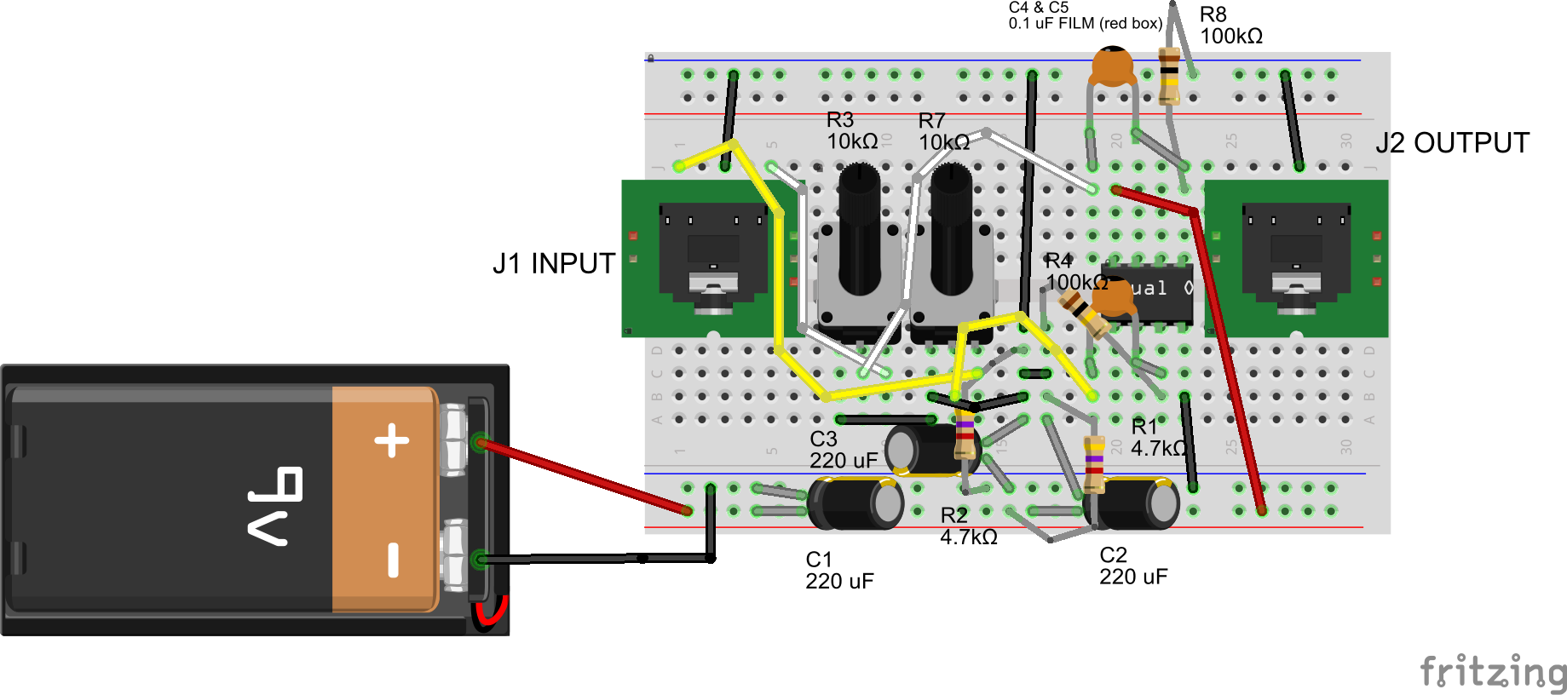

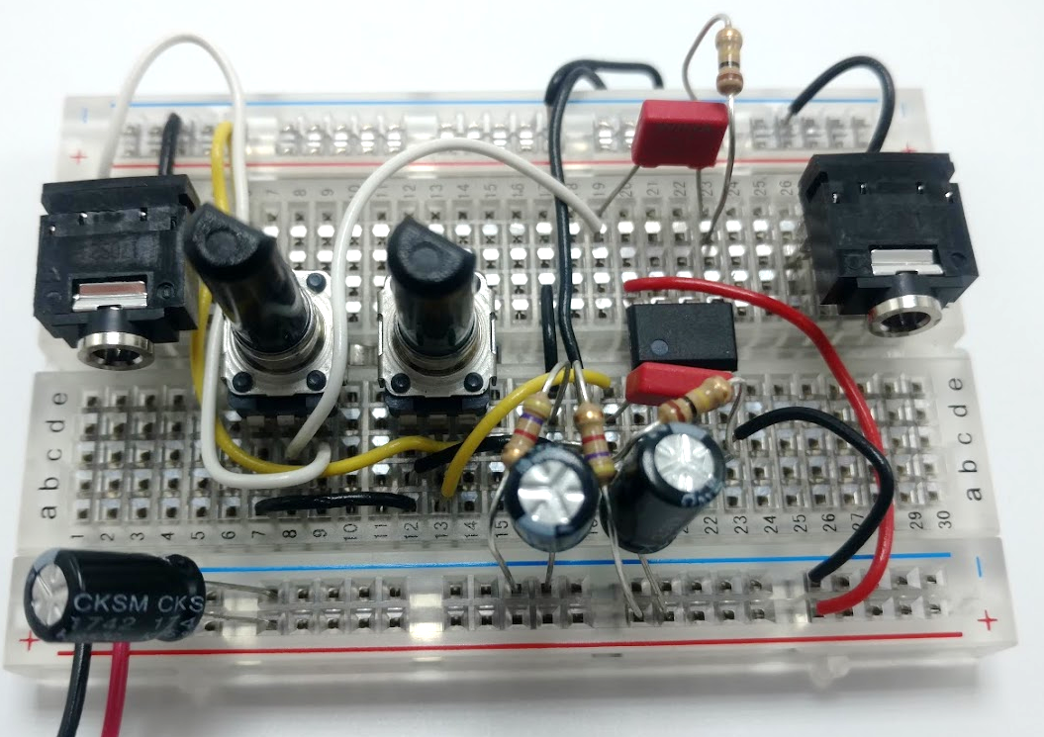

Front view (column 1 on left)

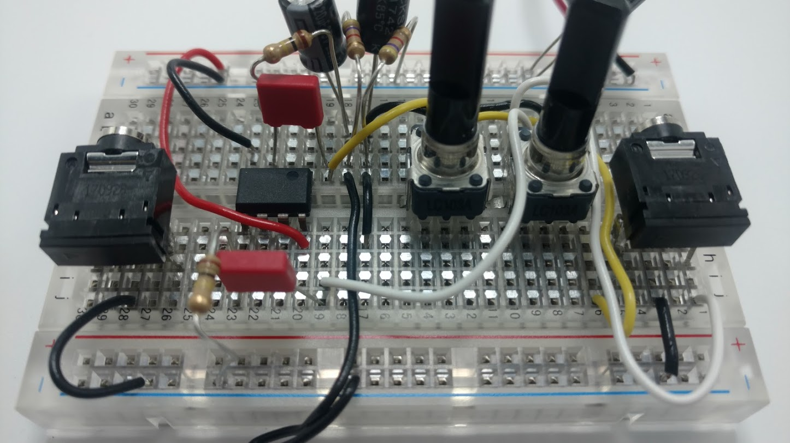

Rear view

## CONNECT the rest of the components

The last part of the construction is to connect up the output portion, including the op-amp’s feedback loop (the 1K and 10K resistors) that set the gain.

Do not install the battery yet.

## Check your work

Verify the battery clip red and black leads connect as shown.

Verify the polarity of the three electrolytic capacitors.

Verify the IC pin 1 is in the lower left.

Look for shorts between component leads.

Look for wires stuck in “off by a row”.

## Test it

Connect the output to headphones and set the volume to zero (full counter clockwise). Connect the input to your source (cellphone, etc).

Connect the 9V battery. Then slowly turn up the amplifier volume. Adjust the volume to the desired level. You’ll need to turn both knobs, one controls the left, the other controls the right.

If building this as a permanent amplifier the use of a “dual gang” pot would let you control both channels at the same time. With the two independent controls you can adjust the balance; think of it as a feature, not a bug.

# The good stuff

This document and all of the source files associated with this project are Copyright 2018 by the Audio Builders Workshop (ABW).

<https://www.facebook.com/groups/AudioBuildersWorkshop/>

a working group of the Boston AES

<http://bostonaes.org/>

All materials are licensed by the ABW under the Creative Commons Attribution-Share-Alike license CC-BY-SA: <https://creativecommons.org/licenses/by-sa/4.0/legalcode>



Design and this part of the documentation developed by Clockworks Signal Processing LLC for ABW.



<http://clk.works/>